FULL APPLICATION

TEMPLATE with instructions for project descriptions within the field of Strategic Vehicle Research and Innovation (FFI).

The total number of pages in the project description should not exceed 15 (excluding summary, cover page, table of contents) in font size 11. If a longer project description is needed the applicant must contact the programme-management to obtain special dispensation.

The project description constitutes the primary basis for assessing and reviewing the application.

Applicants are recommended to read the FFI roadmap, call texts and instructions how to apply and report and other information that can be found on the FFI website, https://ffisweden.se/en, before writing their applications. All documents referred to in this template can be found on the website.

The applications that meet the formal requirements will be evaluated against the assessment criteria by an extern quality review group, who are appointed by Vinnova. The application is assessed in competition with other applications received. The review group adheres to professional secrecy as if they were under the employment of the agency.

This page along with tips and information written in cursive format should be deleted before submitting your application.

Application within FFI <Programme name>
<Insert the title of your project here>

Background and goals for the project
Your text here...
- Provide a background for the project and clearly describe what/which problems or needs the project aims to address and the scope of the problems or needs, describe hypotheses/research issues. If possible, specify concrete and measurable objectives for the project (for example, x % reduction in energy consumption or reduction in fatal road accidents).
- Describe the projects innovation level within the relevant field of application, for example that new knowledge is produced or that current knowledge is applied in new contexts

Potential
Your text here…

Describe the following:
- The project's potential to contribute to FFI's overall goals through relevant issues and level of innovation.
- The project's potential to contribute to the result outcomes/goals of the call.

- The potential of the project to develop new innovative solutions, rather than incremental improvements to existing solutions.

State-of-the-art

Your text here...
Give a description of both how project stems from solid external monitoring and how it relates to the current international state of the art of the research/technology field.

A list of references is to be placed last in the document.

If the project is a continuation of a previous project, clearly state what results have been achieved and how they are used and influence the continuation project. If there is a final report available, it can be submitted as an attachment. Also state the following:

Project number:
Title:
Programme affiliation:
Decision-making agency:
Summary of results and conclusions:

If not, delete this table.

Feasibility

Project contents
Your text here...
Describe the content and setup of the project. The description should embrace different work packages content, role and responsibility of leaders and other participants and defined deliverables/milestones. Describe how the work packages will be evaluated against the set goals.

Also describe working and research methodology (scientific hypothesis and methods where it is relevant).

Then give a more detailed description of the contents of each respective activity/work package and specify who does what. Feel free to use the format below:

<Work Package (WP) no X> | <Name of activity/work package (WP)>
Leader (role and responsibility)
Other participants (roles and responsibilities)
Description of contents
Method/approach (when relevant)
Delivery and evaluation

Scheduling
Your text here...
Specify the project time schedule, start and end dates, showing important activities/work packages and milestones, as well as when different deliveries can be expected. A simple Gantt diagram and a table of milestones, as shown in the example below, may be helpful.

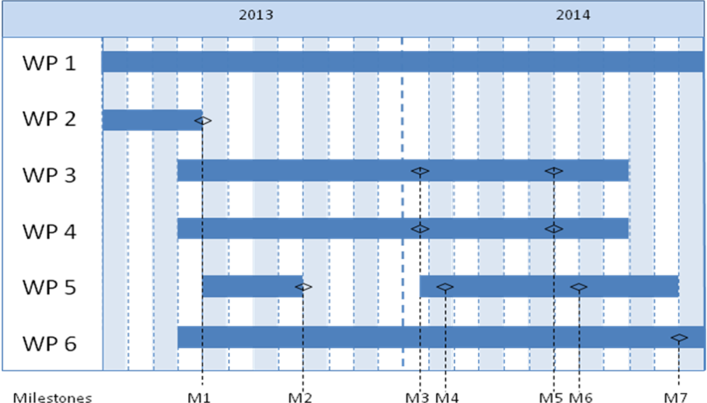

Milestone | Description | Date
M1
M2
M3
Mxx

Project financing
Your text here...
The project financing per work package should be presented in the table below.

 |  | Budget per participating party |  |  |  |  | Total budget/WP
 |  | <Party 1> |  | <Party 2> |  | <Party x>
<WP1>
<WP2>
<WPx>
TOTAL budget per part

Personnel costs and wages for universities could be based on full actual costs where indirect costs must be presented separately. The industry and others may have indirect costs of a maximum of 30% of wage costs. These must be reported separately.

The table below can be used to specify the type of costs arising in the project.

Cost specification | Description
Equipment, facilities

Consultancy costs, licenses

Other direct costs incl. travelling costs
Other costs

Describe how the project aims to realise the potential of spreading/utilizing the results

Actors
Your text here….
Describe
- composition, competence and ability as well as commitment of the actor constellation in relation to project objectives and implementation.
- participation from need owners, users/customers, product/process/system owners and actor(s) with the intention of taking forward expected results.
- how project management should be organized.
- any control and reference groups.

CV (a template is available at https://ffisweden.se/en) needs to be submitted for the project manager, work package leaders and other key personnel so that the project participants competence and abilities can be assessed.

Other relevant information about the parties can also be submitted here.

If subcontractors are to be procured (for example consultants) this must be specified along with the purpose and extent of their involvement in the project.

Equality
Your text here….
Many problems, results and solutions can seem to be gender neutral, but they still affect women and men differently. How do you intend to take this into account in this project and how can it affect the project's effects?

- Describe how the project team is composed regarding gender distribution, but also the distribution of power and influence between men and women.

- Describe how equality aspects have been integrated in the project.
- Describe equality aspects (gender and gender perspective) that can be important to take into consideration in relation to the projects field of study, solutions, and effects.

References
List your references (scientific publications, monographs, conference articles etc.) here. Be restrictive when referring to websites as these have not been “quality reviewed” in the same ways as a publication and the addresses have a tendency to quickly become obsolete.
The “References” section can be omitted if it is not needed.

