FULL APPLICATION

TEMPLATE with instructions for project descriptions within the field of Strategic Vehicle Research and Innovation (FFI).

The total number of pages in the project description should not exceed 15 (excluding summary, cover page, table of contents) in font size 11. If a longer project description is needed the applicant must contact the programme-management to obtain special dispensation.

The project description constitutes the primary basis for assessing and reviewing the application.

Applicants are recommended to read the FFI roadmap, call texts and instructions how to apply and report and other information that can be found on the FFI website, https://ffisweden.se/en, before writing their applications. All documents referred to in this template can be found on the website.

The applications that meet the formal requirements will be evaluated against the assessment criteria by an extern quality review group, who are appointed by Vinnova. The application is assessed in competition with other applications received. The review group adheres to professional secrecy as if they were under the employment of the agency.

This page along with tips and information written in cursive format should be deleted before submitting your application.

Application within FFI <Programme name>
<Insert the title of your project here>
Date:

Is it a reworked application that has previously been assessed by the FFI quality review group?
Yes No

If yes, specify the reference number:

Describe shortly what is new or changed from your previous application

Enter the program's focus area or the equivalent to which the application is directed. Several answers in descending order can be given if the call text allows that.

The coordinator is responsible for submitting the application and who is then responsible for communication with and reporting within the programme.

Table of contents

Table of contents 3
Background and objectives of the project 1
Potential 1
State-of-the-art 2
Feasibility 3
Project contents 3
Scheduling 3
Project financing 4
Actors 4
Equality 5
References 5

Right-click the table of contents to find the function for updating contents and page numbers.

You have three levels of headings at your disposal (Heading 1, 2 and 3).

Background and objectives of the project
Your text here...
- Briefly describe the background and the problem(s)/needs (including hypotheses/research questions) that the project aims to address, as well as their scope. If possible, specify concrete and measurable objectives for the project (e.g., reduced energy consumption by x% or a reduction in traffic fatalities).
- Describe the project’s level of innovation within the relevant application area, for example, whether new knowledge is being generated or existing knowledge is being implemented in a new context.

Potential
Your text here…

Describe the following:
- The project proposal’s potential to contribute to sustainable road transport and Sweden’s competitiveness.
- The project proposal’s potential to contribute to the call’s target outcomes.
- The project proposal’s potential to develop new innovative solutions rather than incremental improvements of existing ones.

State-of-the-art

Your text here...
Describe both how the project is based on thorough external monitoring and how it relates to current international state of the art of the research/technology field.

A list of references is to be placed last in the document.

If the project is a continuation of a previous project, clearly describe the achieved results and how they are how they are being used or influence the continuation project. A summary of the results should be attached as an appendix, according to the template. Also provide the following:

Project number:
Title:
Programme affiliation:
Decision-making agency:
Summary of results and conclusions:

If not, delete this table.

Feasibility

Project contents
Your text here...
Describe the content and setup of the project. The description should embrace different work packages content, role and responsibility of leaders and other participants and defined deliverables/milestones. Describe how the work packages will be evaluated against the set goals.

Also describe working and research methodology (scientific hypothesis and methods where it is relevant).

Then give a more detailed description of the contents of each respective activity/work package and specify who does what. Feel free to use the format below:

<Work Package (WP) no X> | <Name of activity/work package (WP)>
Leader (role and responsibility)
Other participants (roles and responsibilities)
Description of contents
Method/approach (when relevant)
Delivery and evaluation
Allocated hours

Scheduling
Your text here...
Specify the project time schedule, start and end dates, showing important activities/work packages and milestones, as well as when different deliveries can be expected. A simple Gantt diagram and a table of milestones, as shown in the example below, may be helpful.

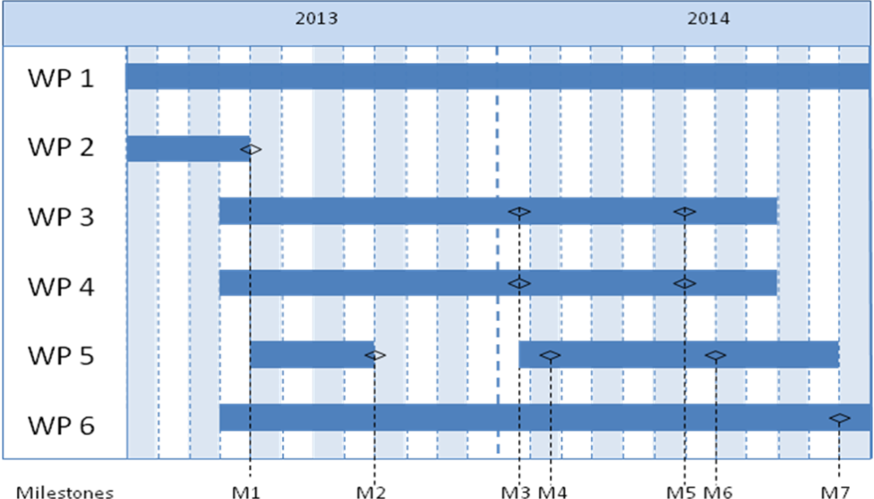

Milestone | Description | Date
M1
M2
M3
Mx

Project financing
Your text here...
The project financing per work package should be presented in the table below.

 |  | Budget per participating party |  |  |  |  | Total budget/WP
 |  | <Party 1> |  | <Party 2> |  | <Party x>
<WP1>
<WP2>
<WPx>
TOTAL budget per part

Personnel costs and wages for universities could be based on full actual costs where indirect costs must be presented separately. The industry and others may have indirect costs of a maximum of 30% of wage costs. These must be reported separately.

The table below can be used to specify the type of costs arising in the project.

Cost specification | Description
Equipment, facilities

Consultancy costs, licenses

Other direct costs incl. travelling costs
Other costs

Describe how the project aims to realise the potential of spreading/utilizing the results

Actors
Your text here….
Describe:
- The composition, competence, capacity, and level of commitment of the consortium/participants in relation to the project objectives and implementation.
- Participation from end-users, customers, product/process/system owners, and other actors intended to further develop the expected results.
- How the project management will be organized.
- Any steering and reference groups.

CV (a template is available at https://ffisweden.se/en) needs to be submitted for the project manager, work package leaders and other key personnel so that the project participants competence and abilities can be assessed.

Other relevant information about the parties can also be submitted here.

If subcontractors are to be procured (for example consultants) this must be specified along with the purpose and extent of their involvement in the project.

Equality
Your text here….
Many problems, results and solutions can seem to be gender neutral, but they still affect women and men differently. How do you intend to take this into account in this project and how can it affect the project's effects?

- Describe how the project team is composed regarding gender distribution, but also the distribution of power and influence between men and women.

- Describe how equality aspects have been integrated in the project.
- Describe equality aspects (gender and gender perspective) that can be important to take into consideration in relation to the projects field of study, solutions, and effects.

References
List your references (scientific publications, monographs, conference articles etc.) here. Be restrictive when referring to websites as these have not been “quality reviewed” in the same ways as a publication and the addresses have a tendency to quickly become obsolete.
The “References” section can be omitted if it is not needed.

