TEMPLATE with instructions for a preparatory study for system demonstrator - project descriptions within the field of Strategic Vehicle Research and Innovation (FFI), sub-program Accelerate.

The total number of pages in the project description should not exceed 5 (excluding cover page, summary, table of contents) in font size 11.

The project description constitutes the primary basis for assessing and reviewing the quality of an application.

Applicants are recommended to read the FFI program road map, call texts and instructions how to apply and report and other information that can be found on the FFI website, https://ffisweden.se/en, before writing their applications.

The application will be assessed by an external quality review group appointed by Vinnova. The review group adheres to professional secrecy as if they were under the employment of Vinnova.

If the planned project is a technology demonstration and that challenges are largely absent regarding business models, infrastructure, regulations and standards as well as behavior, then FFI Accelerate is probably not the right subprogram for the application. However, it may be a relevant application to one of the other FFI sub-programmes.

Tips and information is written in this format. You should delete the tips and this page before submitting your document.

Pre-study Application within FFI Accelerera
<Insert the title of your project here>
Date:

Is it a reworked application that has previously been assessed by the FFI quality review group?
Yes No

If yes, specify the reference number:

Describe shortly what is new or changed compared with the previous application:

Summary
Your text is written here...

The summary must be no more than one page long and include:
- Background and goals of the project: what problem is to be solved, what the project is expected to achieve (what benefits) and who is the intended user.
- The potential of the project, in particular the different system perspectives:
- Behaviour, culture
- Business models
- Regulatory framework and standardisation (”policy”)
- Infrastructure, physical and digital
- Technology, products, services and processes
- State-of-the art
- Implementation and utilization, including the duration of the project and the total cost and funding applied for.
- Actors:
- Which organization is the main applicant (coordinator), responsible for submitting the application and who is then responsible for communication with and reporting within the program.
- Other partners involved in the project.

Table of contents

Summary
Background and goals for the project 1
Potential 1
External monitoring/state-of-the-art 1
Feasibility Project content 1
Scheduling 2
Project financing 3
Utilization 3
Actors 3
Equality 4
References 4

Right-click the table of contents to find the function for updating contents and page numbers.

You have three levels of headings at your disposal (Heading 1, 2 and 3).

Background and goals for the project
Your text here…
- Provide a background for the project and clearly describe what/which problems or needs the project aims to address and the scope of the problems or needs, describe hypotheses/research issues. If possible, specify concrete and measurable objectives for the project (for example, x % reduction in energy consumption or reduction in fatal road accidents).
- Describe the projects innovation level within the relevant field of application, for example that new knowledge is produced or that current knowledge is applied in new contexts.

Potential
Your text here…

Describe the following:
- The potential of the project to contribute to the sub-program as described in FFI's roadmap, in particular the system perspectives:
  - Behavior, culture
  - Business models
  - Regulatory framework and standardization ("policy")
  - Infrastructure, physical and digital
  - Technology, products, services and processes
- The projects contribution towards accelerating the implementation that is needed to, in the long term, achieve strategic objectives as described in the FFI roadmap.
- If the project refers to a mature field of study, does the project lead to large potential improvements in line with the FFI roadmap?

External monitoring/state-of-the-art
Your text here...
Briefly describe the level of knowledge in the area on an international and national level, and how the project relates to this knowledge. If deemed relevant, also describe how the project relates to state-of-the-art research in the field of study.

Feasibility
Project content
Your text here...
Describe the content and setup of the project.

The preparatory project for a system demonstrator addresses the system challenges (describe):
- Behavior, culture
- Business models
- Regulatory framework and standardization ("policy")
- Infrastructure, physical and digital
- Technology, products, services and processes.

Also describe working and research methodology (scientific hypothesis and methods where it is relevant).

Then give a more detailed description of the contents of each respective activity/work package and specify who does what. Feel free to use the format below:

<Work Package (WP) no X> | <Name of activity/work package (WP)>
Leader (role and responsibility)
Other participants (roles and responsibilities)
Description of contents
Method/approach (when relevant)
Delivery and evaluation

Scheduling

Your text here...
Specify a timetable for the project that shows start and end dates along with important activities/work packages. A simple Gantt-chart can be provided.
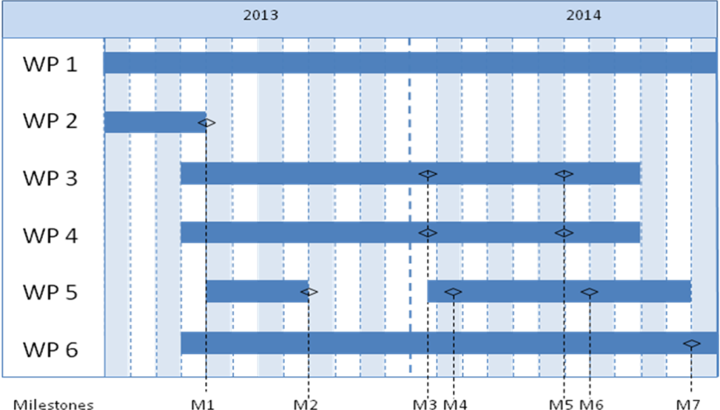

Project financing
Your text here...
The project financing per work package is to be presented in the table below.

 |  | Budget per participating party |  |  |  |  | Total budget/WP
 |  | <Party 1> |  | <Party 2> |  | <Party X>
<WP1>
<WP2>
<WPx>
TOTAL budget per part

Utilization
Your text here...
Describe how the project aims to realise the potential of spreading/utilizing the results.

Actors
Your text here….

Describe the constellation of actors in Table 1. Add rows if necessary.

Tabell 1. Projektparter
Organisation | Role i the project | Number of person hours: estimated for the entire project time | Total personnel cost for the organization's project participation, including indirect cost

Explain why each project party is an important part of the consortium and the role of the project party.

CV (according to template available at the page for the call at vinnova.se) needs to be submitted for the project manager, work package leaders and other key personnel so that the project participants competence and abilities can be assessed.

Other relevant information about the parties can also be submitted here.

If sub-contractors are to be procured (for example consultants) this must be specified along with the purpose and extent of their involvement in the project.

Specify the actors who are linked to the project in one way or another but who are not project parties. For example, it can be organizations that are part of a reference group. Describe their role and the extent to which they are involved in the project, including the names and functions of the contact persons.

Equality
Your text here….
Many problems, results and solutions can seem to be gender neutral, but they still affect women and men differently.
- Describe how the project team is composed regarding gender distribution, but also the distribution of power and influence between men and women.
- Describe how equality aspects have been integrated in the project.
- Describe equality aspects (gender and gender perspective) that can be important to take into consideration in relation to the projects field of study, solutions, and effects.

References
List your references (scientific publications, monographs, conference articles etc.) here. Be restrictive when referring to websites as these have not been “quality reviewed” in the same ways as a publication and the addresses tend to quickly become obsolete.

The “References” section can be omitted if it is not needed.

